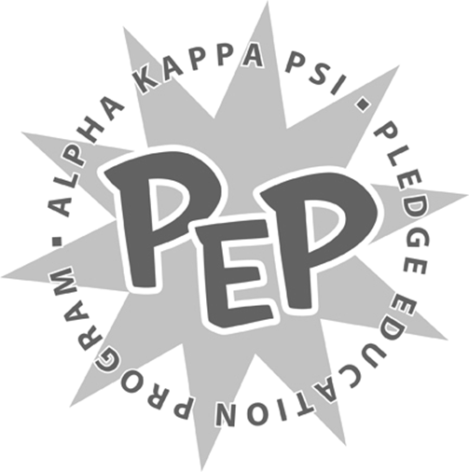

<Insert Semester and Year>
<Insert Pledge Class >

Sweet Genius Project

<Insert Pledge Class >,

Read carefully for your next task. You are to bake a seven (7) layer cake. Each layer should be a different kind of cake and should be decorated to reflect the unique personality of each member of the Beta Iota Chapter of Alpha Kappa Psi’s Executive Board. Each of you must understand the layers and what they represent. It must be edible.

This will be due to the Brotherhood on <Insert Date and Time>. If you have any questions, please direct them immediately to myself or <Insert Pledge Master’s Name>.

Sincerely,
<Insert VPM’s Name>
Vice President of Membership
Alpha Kappa Psi – Beta Iota Chapter

