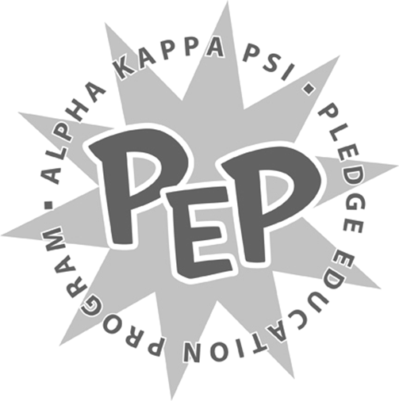

<Insert Semester and Year>
<Insert Pledge Class>

ΑΚΨ Road Trip Project

<Insert Pledge Class>,

Please read the following carefully and in its entirety. Failure to follow all of the instructions will hinder your successful completion of the assignment.

The purpose of this assignment is to showcase your research and planning abilities. You will also learn more about the vast expanse of the Alpha Kappa Psi presence across the country. Your goal is to create the trip that is the most fun and meets brothers from across the country while remaining at a reasonable price.

For this assignment, you are to plan a cross country networking and sightseeing road trip. Along the way, the travelers will be stopping and staying with different Alpha Kappa Psi chapters. There are many benefits to meeting distant members of Alpha Kappa Psi. The successful completion of this trip would not only build the connections of the individuals to other chapters, but increase the reputation of the Beta Iota Chapter as a whole. In addition, the traveling brothers would be able to see the entire country, an opportunity not many Americans are afforded.

Your project specifics are as follows:

- You must make these general assumptions:
  - You must enter all 48 Contiguous U.S. states (all but Hawaii and Alaska)
  - You will be starting at the University at Buffalo
  - The trip will take place over the Summer break and cannot exceed 90 days
  - Brothers will be driving one vehicle the entire trip, no flights or boats
  - The vehicle can travel 250 miles on a full tank of gas
  - The vehicle costs $50 to fill the gas tank from empty to full
  - There are 4 brothers traveling in the vehicle
  - You can ignore weather and traffic variations
  - Since we will be staying with brothers at different chapters, you can ignore hotel costs
  - The only maintenance costs you must account for is a $20 oil change every 3,000 miles
  - The residence of Alpha Kappa Psi members is located at their University campus
- You must make a Map of the proposed journey
  - This must be large enough to see the entire trip
  - States, Cities, and Points of Interest must be labeled
  - Pins may be used to mark locations
  - A colored route must be drawn to show the path
- You must make a Travel Log for the entire trip
  - Printed and stapled
  - Every stop must be noted
    - This includes every rest stop (bathroom and food), attraction, or chapter visit
  - This must be divided into days
  - Must denote the distance and time traveled between stops
  - Must notate somehow when a new state is entered
- You must make a Networking List
  - This is a chronological list of the Chapters that are stayed at
  - Must include the following:
    - Day
    - Chapter
    - School
    - City, State
  - For each chapter there also needs to be an actual contact person to set up the arrangements
    - Name and position (if any)
    - Email
- You must make a Financing Package
  - Printed Excel spreadsheet showing estimated costs of the trip
  - Must show total cost and cost per brother
  - Must account for food and costs of attractions (if any)
- You must make a Proposal
  - Typed and printed
  - Must include the following:
    - Benefits and reasons for taking the trip
    - Proposal for subsidizing some or all of the costs
- You must make a Travel Guide
  - Typed, printed, and bound in some format
  - Must be in color and have an entertaining visual impact
  - Must include the following:
    - For each city visited, a local eatery that is recognized as a ‘must visit’
    - A highlight of each college campus visited (can include a landmark, famous building, etc.)
    - At the end, must have a list of suggestions for:
      - Some kind of merchandise or memorabilia to collect at each University
      - A collection of something memorable from each state (ex. magnets)
  - Every entry (University, City, or Attraction) should be at least ½ page and include photos and a paragraph description on what is important to see

- You must follow these rules
  - All 48 states must be entered and driven partially through with some evidence of being there (receipt, picture, etc.)
  - A rest stop must be made when traveling every 3 hours
  - All stops for sleep must be at least 8 hours at an Alpha Kappa Psi Chapter residence
  - You can only stay at an Alpha Kappa Psi residence for a maximum of two nights
  - At minimum, the following cities / attractions must be either visited or the location of an extended stay
    - Atlanta, GA
    - Augusta, ME
    - Austin, TX
    - Boston, MA
    - Chicago, IL
    - Cleveland, OH
    - Dallas, TX
    - Daytona Beach
    - Denver, CO
    - Detroit, MI
    - Glacier National Park
    - Grand Canyon
    - Indianapolis, IN
    - Las Vegas, NV
    - Los Angeles, CA
    - Miami, FL
    - Minneapolis, MN
    - Mt. Rushmore
    - Myrtle Beach
    - Nashville, TN
    - New Orleans, LA
    - New York, NY
    - Orlando, FL
    - Philadelphia, PA
    - Phoenix, AZ
    - Red Rocks Park
    - Redwood Forest
    - San Diego, CA
    - San Francisco, CA
    - Seattle, WA
    - St. Louis, MO
    - Tampa, FL
    - The Alamo
    - Washington, DC
    - Yellowstone National Park

As you can see this is an intensive project, so get started early. All of these requirements are only the minimums and you are expected to go above and beyond as always. You will be presenting your plan and turning in your documents on <Insert Date and Time>. You will have <Insert Time Limit> to present.

If you have any questions, please direct them immediately to <Insert Pledge Master’s Name>.

Sincerely,

Master of Rituals

