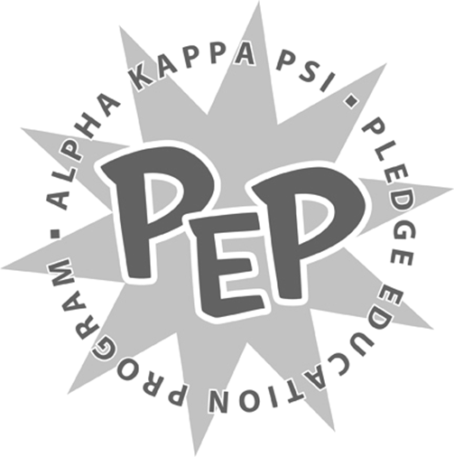

<Insert Semester and Year>
<Insert Pledge Class >

Project Crest

<Insert Pledge Class >,

The Executive Board of Alpha Kappa Psi – Beta Iota Chapter has passion for this fraternity that goes beyond their call of duty. The Brotherhood would like for you to mimic that passion in the form of creating crests for each of the executive board members. All crests must be unique and incorporate individual characteristics for each of the executive board members.

Some suggestions for individual characteristics include, but are not limited to, incorporating:
- Favorite color(s)
- Favorite artist/band(s)
- Favorite book/character(s)
- Favorite show/movie(s)
- Favorite animal(s)
- Favorite quote(s)

You are free to include anything else you deem is necessary.

Each of the crests must clearly denote who it is intended for and their title.

Use as many resources as you can. Your interviews with the executive board members should uncover many facts that can be incorporated into these crests. However, please bear this in mind: These crests are meant to be given to the Executive Board of Alpha Kappa Psi – Beta Iota Chapter as a surprise. So, in turn you may utilize the rest of the Brotherhood for help on this assignment.
Put your creativity to the test and be as creative as possible! Remember, you are making gifts on behalf of the chapter. Do not disappoint the entire Brotherhood in presenting this gift to the Executive Board.
This will be due to the Brotherhood on <Insert Date and Time>. If you have any questions, please direct them immediately to myself or <Insert Pledge Master’s Name>.

Sincerely,
<Insert VPM’s Name>
Vice President of Membership
Alpha Kappa Psi – Beta Iota Chapter

