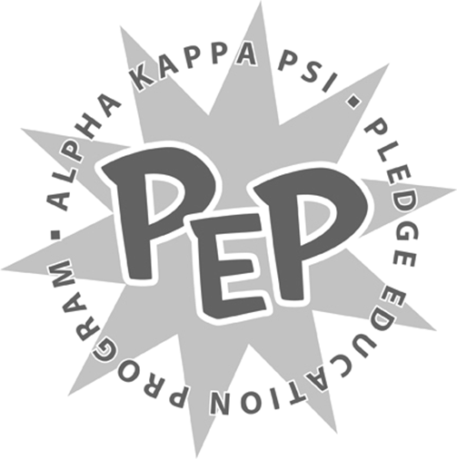

<Insert Semester and Year>
<Insert Pledge Class >

Brother Song Project

<Insert Pledge Class >,

Please read the following carefully and in its entirety. Failure to follow all of the instructions will hinder your successful completion of the assignment.

The purpose of this assignment is to further develop your understanding of the names of the Beta Iota Chapter brothers. In this assignment, you are asked to create lyrics for a song that represent the brothers of the Beta Iota Chapter. The assignment will help you better associate yourselves with the brothers.

As usual, you are all expected to work together, as a team, to create the brother song. You may choose any song that is appropriate and you must rewrite the lyrics in a way that each and every brother’s name is included (all names must be preceded with the appropriate Mr. or Ms.). The lyrics should also consist of specific lyrics that either describes the brothers or the Fraternity as a whole. You will also be required to present the song to the brothers of the Beta Iota Chapter; every <Insert Pledge Class> member must be present and participating. The <Insert Pledge Class> is asked to sing the song as one united class so please make sure to rehearse prior to your presentation.

In addition, you will be required to act out a music video at your presentation. You can use whatever means of technology you'd like, as well as any additional props you may want to incorporate. We recommend that you go above and beyond the minimum requirements for the assignment, as this will demonstrate your efforts to the Beta Iota Chapter. You will present this on <Insert Date and Time>. You will have <Insert Time Limit> to present. Arrive outside <Insert Location and Time> for further instructions. If you have any questions, feel free to direct them to myself or <Insert Pledge Master’s Name>.

Sincerely,
<Insert VPM’s Name>
Vice President of Membership
Alpha Kappa Psi – Beta Iota Chapter

